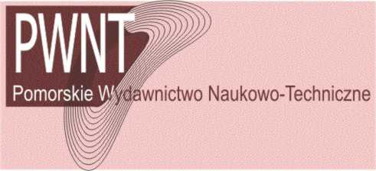
PWNT – Pomeranian Science and Technology Publishers
Polish Consultants Society, Gdansk Branch
80-309 Gdańsk; ul. Grunwaldzka 311 (c/o Nov-Weld)
tel 58 5521536 fax 58 3457946 Tax ID 586-20-61-953
tel 58 3472018 fax 58 3025419 tkp@konsulting.gda.pl
Kredyt Bank, III Gdansk Branch, Account No 93 1500 1285 1212 8003 3046 0000

Title of the book: Diagnosis of Processes and Systems .......................................... PWNT 2009

COPYRIGHT TRANSFER AGREEMENT

Title of the contribution (chapter): ..................................................................................................….
...............................................................................................................................................................
Authors: ......….................................................................................................................................….

Submit this signed copyright form to PWNT, Pomeranian Science and Technology Publishers (tkp@konsulting.gda.pl). The purpose of this document is to protect the interests of both sides, the PWNT and the Authors, and, in particular, to determine the rights concerning the publication and the way of using the above contribution.

It is herein agreed that: The copyright to the contribution identified above is hereby transferred to PWNT, the Pomeranian Science and Technology Publishers, (for U.S. government employees: to the extent transferable). The copyright transfer covers the exclusive right to reproduce and distribute the contribution in whole or in part, using any form of media, now or hereafter known.

Each of the authors retaims the following rights:
- the right to copy the contribution (material) for their own use;
- all other proprietary rights to this material, including patent rights;
- the right to publish their contribution on their personal Web page provided that
  - any user has a free and unlimited access to this material,
  - together with such an electronic version it is clearly pointed out, by adding “© PWNT”, that the copyright for this contribution is held by PWNT, and
  - there is a link to the PWN homepage (http://konsulting.gda.pl/pwnt.html);
- the right to use the material for educational purposes;
- the right to revise/republish the material, and to re-use any portion of the contribution in all forms of media, requires a proper PWNT citation and no permission or a fee.

The undersigned hereby warrants that the material is original and that he/she is the author of the chapter; to the extent the chapter incorporates text passages, figures, data or other material from the works of others, the undersigned has obtained necessary permissions.

The undersigned: (a) represents that he/she has the power and authority to make and execute this assignment; (b) agrees to indemnify PWNT against all losses, costs and expenses arising from any claims made by other parties concerning the authorship of the contribution or rights to publish it. For jointly authored chapters, all joint authors should sign, or one of the authors should sign as the authorized agent for the others.

author signature date

author signature date

Statements and opinions expressed in the book are these of the authors and not those of the editors or PWNT. No responsibility is accepted for the accuracy of information contained in the book. PWNT assumes no responsibility or liability for any damage or injury to persons or property arising out of the use of any instructions, methods or ideas contained inside the book.
From the Publisher’s point of view, it would be desirable that the full-text version be made available from the Author’s Web page only after a delay of 12 months following the publication of the book, whereas such a delay is not required for the abstract.
It is the responsibility of the authors, not PWNT, to determine whether disclosure of their material requires the prior consent of other parties and, if so, to obtain it.

